# Exercise Sheet 4 – Ice Cream Shop

This application allows the user to select a type of ice cream with different ice cream flavours and a choice of toppings and displays the price.

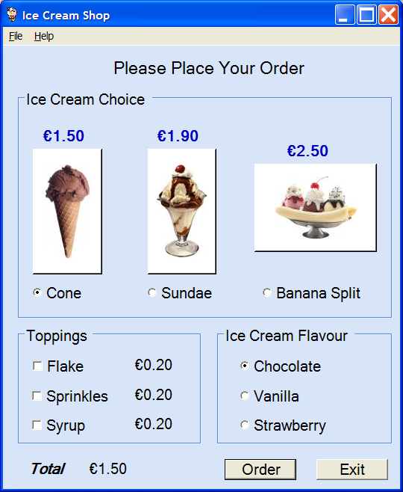

## Details:

* When the application opens the radio button for a Cone and chocolate ice cream should be selected. The price should be displayed in the bottom left in a label at €1.50.
* When the radio button or image for a Sundae is selected, the check box for Syrup should be selected and the radio button for Vanilla ice cream. The correct price should be displayed at €2.10.
* When the radio button or image for a Banana Split is selected a Message Dialog should appear saying: ‘Your banana split comes with chocolate, vanilla and strawberry ice cream’ (see image below) and the radiobuttons for the ice cream choice should be disabled. The correct price should be displayed at €2.50.

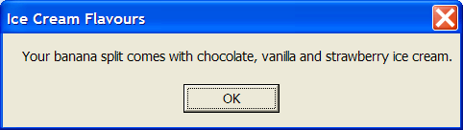

* When the cone or sundae is selected after a banana split, the ice cream check boxes should be enabled again.
* When the user selected additional toppings the price should automatically update accordingly.
* When the order button is pressed, a similar dialog to the image below should be displayed:

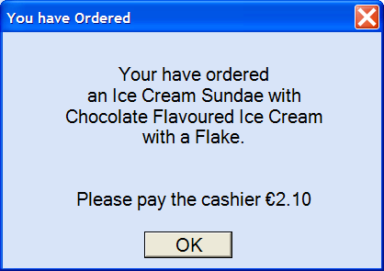

* After the user clicks the OK button on the order dialog, the radio button for the cone should be selected along with the radio button for chocolate ice cream.
* When the Exit button is pressed, the application should close down.